Options Trading Strategy Analyzer
Development Handover Document

Prepared for: Swapnil, Smruthi Organics — personal systematic options trading project
Prepared for discussion with: external developer / development partner
Date: 07 August 2026
Status: Draft for discussion — scope to be refined jointly with developer

1. Purpose and context
This is a personal, non-commercial project. I trade NSE equity options using a systematic, rules-based approach, and over an extended series of working sessions with an AI assistant I have built up several backtested option strategies — a directional call/put debit-spread system, an Iron Condor for range-bound conditions, and a volatility-arbitrage strategy that sells option premium. Each strategy is defined by a precise set of technical indicators, entry/exit rules, and position-sizing logic, and each has been validated against roughly two years of historical NSE equity and options data across 16+ stocks.
Right now this analysis lives entirely inside AI chat sessions: raw CSV files, one-off Python scripts, and results reported back in conversation. That works for exploration, but it does not give me a durable, repeatable way to review results, compare parameter choices, or watch how a strategy performs as new data comes in. I want to move this into a proper application: a single place where the historical data lives, where each strategy's rules and parameters are visible and adjustable, and where results are shown as tables and charts I can actually work with.
The immediate goal is a browser-based backtesting and analysis tool for historical data. A secondary, later goal is to connect the same tool to my broker's live market data API, so I can watch strategies generate signals against real-time prices and refine them over time. The two goals share almost all of the same underlying logic — this document scopes both, but treats the second as a later phase, not part of the first build.

2. What the application should do (plain-English feature list)

2.1 Central data store
- All historical stock price data and options-chain data (currently spread across many CSV files) should be loaded into one proper database, not left as loose spreadsheets — the options-chain files alone run to hundreds of thousands of rows per stock, which is too much for Excel or Google Sheets to handle comfortably.
- There should be a simple way to add new stocks or refresh existing data — I will keep sourcing raw exports from NSE and need to bring them in periodically.
- The tool should tell me, at a glance, what data it currently has (which stocks, which date ranges) so I never analyze something on stale or incomplete data without knowing it.

2.2 Strategy runner (the core screen)
- I should be able to select one of my existing strategies from a list.
- Once selected, the screen should show every parameter that strategy uses — for example the trend-strength threshold, the volume-spike threshold, the take-profit and stop-loss percentages — with its current default value.
- I should be able to change any of those parameter values directly on screen (sliders or input boxes), pick which stocks to test it on, and run the backtest.
- Results should come back as: a set of summary numbers (total profit/loss, number of trades, win rate, average holding period), a bar chart of profit/loss by stock, a profit-over-time chart, and a full table listing every individual trade with its entry date, exit date, exit reason, and profit/loss.

2.3 Strategy builder
- Beyond tweaking an existing strategy's parameters, I want to be able to build a new strategy from scratch: choose which technical indicators go into it (from a library of the indicators already in use, with room to add more later), set a default value for each, and define the rule for when a trade should trigger.
- I should be able to run this new strategy the same way as any built-in one and see the same tables and charts.
- If I like the results, I should be able to save it as a distinct, named version — related to the strategy it was built from, but not overwriting it — so I keep a full history of what I tried and never lose an earlier version by accident.

2.4 Comparing results over time
- Every backtest I run should be saved, not just shown once and discarded — I want to come back later and compare, e.g., “what did this strategy return with a 40% take-profit versus a 50% take-profit,” without re-running anything.
- There should be a screen to select two or more saved runs and see their summary numbers and charts side by side.

2.5 Trade explorer
- A single, filterable table of every trade ever generated, across every strategy and every run — filterable by strategy, stock, date range, and win/loss — so I can inspect specific trades without having to first pick a single run.

2.6 Future phase — live data (not part of the first build)
- Eventually, connect to my broker's market-data API (Zerodha Kite Connect) so the same strategies can be evaluated against live prices, not just historical data.
- This should show me live signals and paper (simulated) profit/loss as they develop — it should not place real orders. Real order placement, if it ever happens, is a separate, explicitly gated feature to design later, not an assumed part of this build.
- This phase depends on the historical tool being solid first, since the same calculation logic needs to be trustworthy before it is pointed at real-time data.

3. User interface description
The application should be browser-based (not a desktop install), single-user, and structured around one main working screen plus three supporting screens, arranged as tabs. A rough wireframe of the main working screen (“Strategy runner”) is below — this is illustrative of the layout and information hierarchy, not a final visual design.
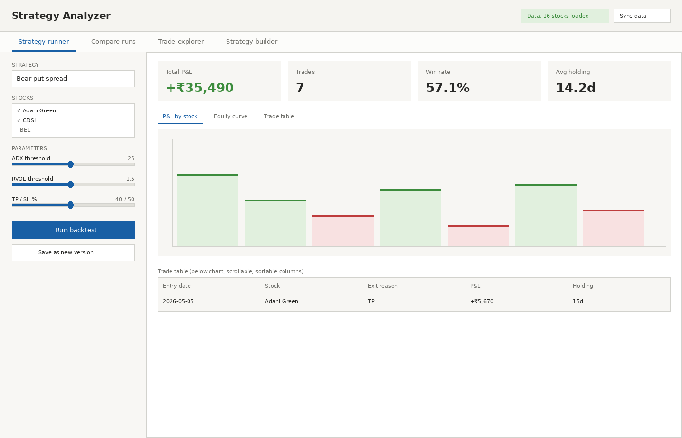
Region-by-region description:
- Header row: application name on the left; on the right, a status indicator showing what data is currently loaded (e.g. “16 stocks loaded”) and a button to re-sync/refresh the underlying data store.
- Tab bar, four tabs: Strategy runner (default/landing tab), Compare runs, Trade explorer, Strategy builder.
- Left panel (Strategy runner tab): a dropdown to pick the strategy, a multi-select list to pick which stocks to include, and then the parameter controls for the selected strategy — these should be generated automatically from that strategy's own list of parameters, so the panel looks different depending on which strategy is selected, without needing separate screens built per strategy. Two buttons beneath: “Run backtest” and “Save as new version.”
- Main panel, top strip: four summary cards — total profit/loss, number of trades, win rate, average holding period.
- Main panel, below the summary cards: a set of sub-tabs switching between a profit/loss-by-stock bar chart, a cumulative profit-over-time line chart, and the full trade table.
- Trade table: one row per trade, sortable columns, at minimum entry date, stock, exit reason, profit/loss, and holding period, with the ability to filter and export.
The other three tabs reuse the same visual language (cards, tables, charts) rather than introducing new UI patterns: Compare runs shows the same summary cards and charts for two or more saved runs side by side; Trade explorer is the same trade table but scoped to all runs instead of one; Strategy builder replaces the parameter list in the left panel with an indicator picker, but keeps the same run/save workflow.

4. Functional requirements
Priority key: Must = required for first release; Should = important, can follow shortly after; Could = nice to have, no committed timeline.

4.1 Data management
ID | Requirement | Priority
FR-1.1 | Import equity price CSVs and options-chain CSVs (NSE export format) into a structured database. | Must
FR-1.2 | Detect and handle known data-quality issues on import: comma-formatted numbers, duplicate rows, and “glued” rows where two records were exported without a line break. | Must
FR-1.3 | Compute and store standard technical indicators (moving averages, ADX/DMI, Supertrend, MACD, relative volume, RSI) once per stock, reusable by every strategy rather than recomputed per run. | Must
FR-1.4 | Display which stocks and date ranges are currently loaded, and flag any stock with an incomplete data set (e.g. missing a quarter of options data). | Should
FR-1.5 | Provide a repeatable way to add new stocks or refresh existing ones without a developer's involvement each time. | Should

4.2 Strategy runner
ID | Requirement | Priority
FR-2.1 | List all available strategies for selection. | Must
FR-2.2 | On selecting a strategy, display every parameter it uses, with its current default value. | Must
FR-2.3 | Allow each parameter to be edited before running (numeric input or slider, with sensible min/max/step per parameter). | Must
FR-2.4 | Allow selection of one or more stocks to run the strategy against. | Must
FR-2.5 | Execute the backtest and return: summary statistics, a profit/loss-by-stock chart, a cumulative profit/loss-over-time chart, and a full trade-level table. | Must
FR-2.6 | Persist every run (parameters used, stocks, results, timestamp) rather than discarding it after display. | Must

4.3 Strategy builder
ID | Requirement | Priority
FR-3.1 | Provide a library of available indicators/factors, each independently configurable (period, threshold, comparison direction). | Should
FR-3.2 | Allow composing a new strategy by selecting a set of factors, setting a trigger rule (e.g. “N of M factors true”), and choosing a trade structure from the existing set (debit spread, credit spread, straddle, iron condor). | Should
FR-3.3 | Allow running a newly composed strategy through the same engine and viewing the same outputs as any built-in strategy. | Should
FR-3.4 | Allow saving a composed strategy as a new, named, versioned entry, tagged with which strategy (if any) it was derived from — never silently overwriting an existing strategy. | Should

4.4 Comparison and exploration
ID | Requirement | Priority
FR-4.1 | Allow selecting two or more saved runs and viewing their summary statistics and charts side by side. | Should
FR-4.2 | Provide a single trade-level table spanning all strategies and all saved runs, filterable by strategy, stock, date range, and outcome (win/loss). | Should
FR-4.3 | Allow exporting any table (trade-level or summary) to CSV or Excel for offline use. | Could

4.5 Live data (Phase 2 — scoping only, not first build)
ID | Requirement | Priority
FR-5.1 | Connect to Zerodha Kite Connect (or equivalent broker API) to pull live/near-live price and options-chain data. | Could — Phase 2
FR-5.2 | Evaluate existing strategies against live data on a defined polling schedule and surface generated signals. | Could — Phase 2
FR-5.3 | Track simulated (paper) open positions and their running profit/loss — no real order placement in this phase. | Could — Phase 2
FR-5.4 | Any future real order-placement capability must be a separate, explicitly confirmed action per trade, never automatic. | Could — Phase 2, hard constraint if built

5. Non-functional and systemic requirements
Area | Requirement
Platform | Browser-based web application. No desktop install required. Single user (me) — no multi-user accounts or permissions needed for the first build.
Data volume | Must comfortably handle a full options chain per stock (hundreds of thousands of rows per stock per year) and price history across 15–30+ stocks without noticeable slowdown when filtering or charting.
Performance | A single backtest run (one strategy, one stock, ~2 years of data) should return results in a few seconds, not minutes, so parameter tweaking feels interactive.
Data integrity / versioning | Every backtest run must be traceable to the exact parameter set and strategy version used to produce it — no run should silently become ambiguous later (this has already caused a real mistake in the manual process: a stock's lot size was corrected in one place but an earlier result kept using the old, wrong value without anyone noticing).
Extensibility | Adding a new indicator or a new strategy type should not require rebuilding the interface — the UI should generate itself from each strategy's declared parameter list.
Local-first / ownership | All data and results should be stored locally or in an account I control (not a third-party SaaS holding my trading data), given this is personal financial data.
Credentials | Any future broker API key/token must be stored securely (not in plain text in a config file committed anywhere shared) and never logged.
No live trading in Phase 1 | The first build must not place real trades or connect to any order-execution endpoint. This is a hard boundary, not a preference.
Auditability | I want to be able to see, for any historical result, exactly which code/parameter version produced it — a simple version tag or timestamp per run is sufficient.

6. Technical notes for the developer
The core calculation logic — indicator formulas, signal-generation rules, and profit/loss mechanics for each strategy — already exists as validated Python code, developed and tested over many sessions against real historical data. This should be reused, not rebuilt from scratch; a separate technical reference document with the exact locked formulas, parameters, and a full track record across 16+ stocks is available to hand over alongside this one.
My working assumption for the stack (open to the developer's judgment):
- Data storage: a proper embedded analytical database (e.g. DuckDB or SQLite) rather than flat files or spreadsheets — file-based, no server to manage, but able to handle the data volumes above.
- Backend/engine: Python, wrapping the existing indicator and strategy logic.
- Frontend: any browser-based framework the developer is comfortable with, so long as it supports the interactive parameter controls, data tables, and charts described above. I have no fixed preference here — I've sketched this internally as a Python-only Streamlit app for speed of development, but I'm open to a more conventional web front end if the developer has a strong preference.
I am comfortable reviewing and lightly editing code myself (using Cursor), so a codebase that's reasonably readable and not over-engineered for a single-user tool is preferred over a heavily abstracted, enterprise-style build.

7. Phasing and out of scope

7.1 Phase 1 (this build)
- Data ingestion from existing CSV exports into a proper database.
- Strategy runner with parameter tweaking, for all currently-built strategies, on historical data.
- Summary/trade/chart outputs as described in Section 4.
- Run persistence and basic run comparison.

7.2 Phase 2 (later, separate discussion)
- Strategy builder (composing new strategies from an indicator library).
- Live broker data integration and paper-trading signal monitoring.

7.3 Explicitly out of scope for now
- Real order placement / trade execution of any kind.
- Multi-user access, accounts, or permissions.
- Mobile app (browser access on a phone is fine; a dedicated mobile build is not needed).
- Any strategy logic not already defined in the existing validated Python code — this is a tooling project, not a strategy-research project.

8. Open questions for the developer
- Given the data volumes and single-user context, do you agree with DuckDB/SQLite over a hosted database, or is there a reason to prefer something else?
- Any strong preference on frontend framework given the interactivity required (parameter sliders, live-updating charts and tables)?
- How would you approach storing/versioning strategy definitions — database rows, or version-controlled config files (e.g. YAML) that are easier to diff and review in Cursor?
- Rough estimate for Phase 1 alone, and whether Phase 2 (live data) meaningfully changes the Phase 1 architecture if planned for from the start versus bolted on later.

